ITA0601 – MACHINE LEARNING
LAB EXPERIMENTS
EXP-18: Perceptron based IRIS classification
Dataset 1 – Perceptron Based Iris Classification
Sepal Length | Sepal Width | Petal Length | Petal Width | Species
5.1 | 3.5 | 1.4 | 0.2 | Setosa
4.9 | 3.0 | 1.4 | 0.2 | Setosa
4.7 | 3.2 | 1.3 | 0.2 | Setosa
6.4 | 3.2 | 4.5 | 1.5 | Versicolor
6.9 | 3.1 | 4.9 | 1.5 | Versicolor
5.5 | 2.3 | 4.0 | 1.3 | Versicolor
6.3 | 3.3 | 6.0 | 2.5 | Virginica
5.8 | 2.7 | 5.1 | 1.9 | Virginica
7.1 | 3.0 | 5.9 | 2.1 | Virginica
Python Code:
import pandas as pd
from sklearn.model_selection import train_test_split
from sklearn.linear_model import Perceptron
from sklearn.metrics import accuracy_score
data = {
"Sepal_Length": [5.1, 4.9, 4.7, 6.4, 6.9, 5.5, 6.3, 5.8, 7.1],
"Sepal_Width": [3.5, 3.0, 3.2, 3.2, 3.1, 2.3, 3.3, 2.7, 3.0],
"Petal_Length": [1.4, 1.4, 1.3, 4.5, 4.9, 4.0, 6.0, 5.1, 5.9],
"Petal_Width": [0.2, 0.2, 0.2, 1.5, 1.5, 1.3, 2.5, 1.9, 2.1],
"Species": [
"Setosa", "Setosa", "Setosa",
"Versicolor", "Versicolor", "Versicolor",
"Virginica", "Virginica", "Virginica"
]
}
df = pd.DataFrame(data)
df["Species"] = df["Species"].map({
"Setosa": 0,
"Versicolor": 1,
"Virginica": 2
})
X = df[["Sepal_Length", "Sepal_Width",
"Petal_Length", "Petal_Width"]]
y = df["Species"]
X_train, X_test, y_train, y_test = train_test_split(
X, y, test_size=0.3, random_state=42
)
model = Perceptron(max_iter=1000, random_state=42)
model.fit(X_train, y_train)
y_pred = model.predict(X_test)
print("Dataset 1 - Perceptron Classification")
print("Accuracy:", round(accuracy_score(y_test, y_pred) * 100, 2), "%")
new_flower = pd.DataFrame({
"Sepal_Length": [5.1],
"Sepal_Width": [3.5],
"Petal_Length": [1.4],
"Petal_Width": [0.2]
})
prediction = model.predict(new_flower)
names = {
0: "Setosa",
1: "Versicolor",
2: "Virginica"
}
print("Predicted Flower:", names[prediction[0]])
Output:
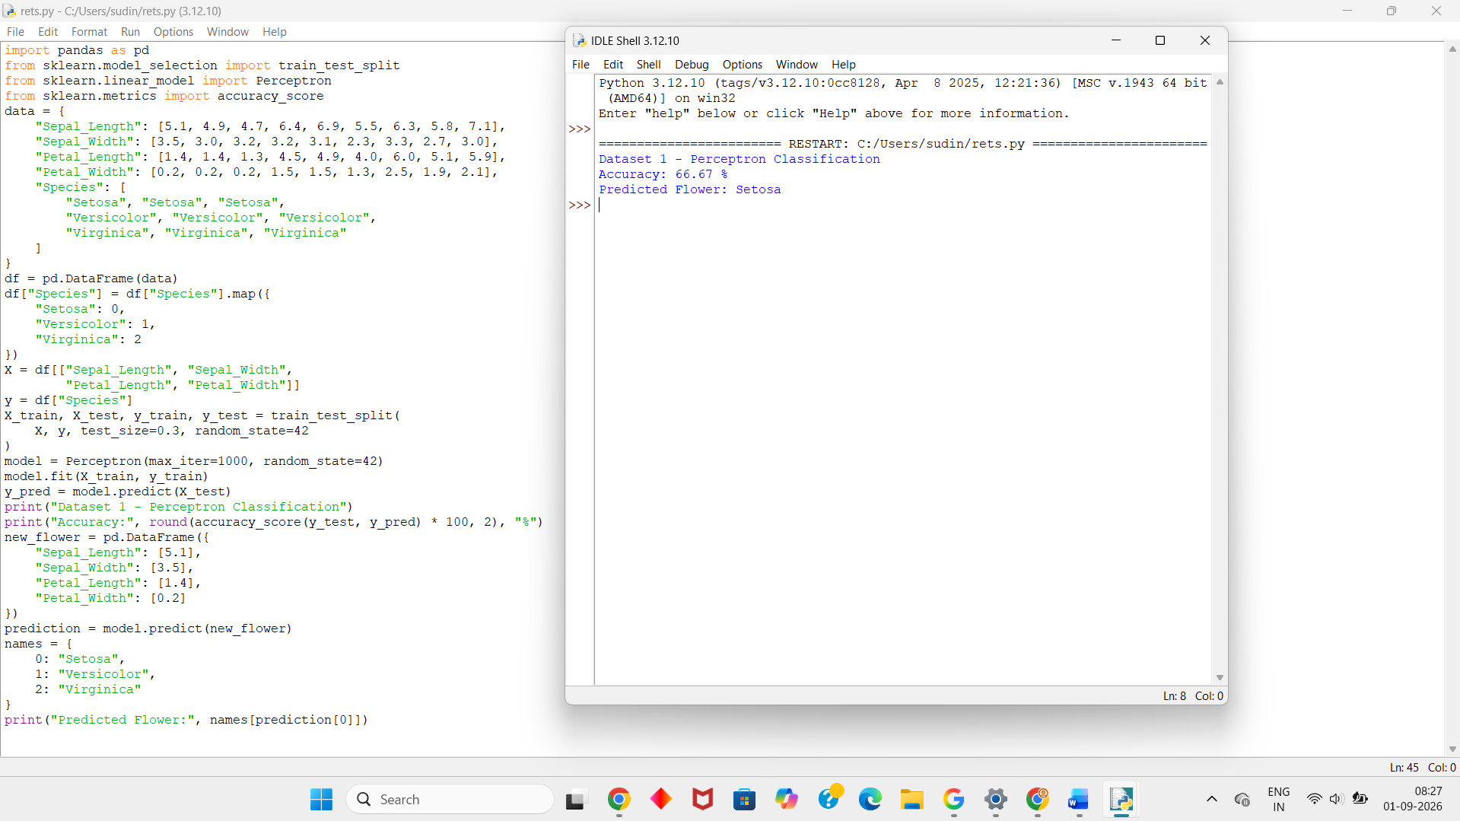
Dataset 2 – Perceptron Based Iris Classification
Sepal Length | Sepal Width | Petal Length | Petal Width | Species
5.0 | 3.4 | 1.5 | 0.2 | Setosa
4.6 | 3.1 | 1.5 | 0.2 | Setosa
5.4 | 3.7 | 1.5 | 0.2 | Setosa
5.9 | 3.0 | 4.2 | 1.5 | Versicolor
6.0 | 2.9 | 4.5 | 1.5 | Versicolor
6.1 | 2.8 | 4.0 | 1.3 | Versicolor
6.5 | 3.0 | 5.2 | 2.0 | Virginica
6.2 | 3.4 | 5.4 | 2.3 | Virginica
6.7 | 3.1 | 5.6 | 2.4 | Virginica
Python Code:
import pandas as pd
from sklearn.model_selection import train_test_split
from sklearn.linear_model import Perceptron
from sklearn.metrics import accuracy_score
data = {
"Sepal_Length": [5.0, 4.6, 5.4, 5.9, 6.0, 6.1, 6.5, 6.2, 6.7],
"Sepal_Width": [3.4, 3.1, 3.7, 3.0, 2.9, 2.8, 3.0, 3.4, 3.1],
"Petal_Length": [1.5, 1.5, 1.5, 4.2, 4.5, 4.0, 5.2, 5.4, 5.6],
"Petal_Width": [0.2, 0.2, 0.2, 1.5, 1.5, 1.3, 2.0, 2.3, 2.4],
"Species": [
"Setosa", "Setosa", "Setosa",
"Versicolor", "Versicolor", "Versicolor",
"Virginica", "Virginica", "Virginica"
]
}
df = pd.DataFrame(data)
df["Species"] = df["Species"].map({
"Setosa": 0,
"Versicolor": 1,
"Virginica": 2
})
X = df[["Sepal_Length", "Sepal_Width",
"Petal_Length", "Petal_Width"]]
y = df["Species"]
X_train, X_test, y_train, y_test = train_test_split(
X, y, test_size=0.3, random_state=42
)
model = Perceptron(max_iter=1000, random_state=42)
model.fit(X_train, y_train)
y_pred = model.predict(X_test)
print("Dataset 2 - Perceptron Classification")
print("Accuracy:", round(accuracy_score(y_test, y_pred) * 100, 2), "%")
new_flower = pd.DataFrame({
"Sepal_Length": [6.1],
"Sepal_Width": [2.9],
"Petal_Length": [4.5],
"Petal_Width": [1.5]
})
prediction = model.predict(new_flower)
names = {
0: "Setosa",
1: "Versicolor",
2: "Virginica"
}
print("Predicted Flower:", names[prediction[0]])
Output:
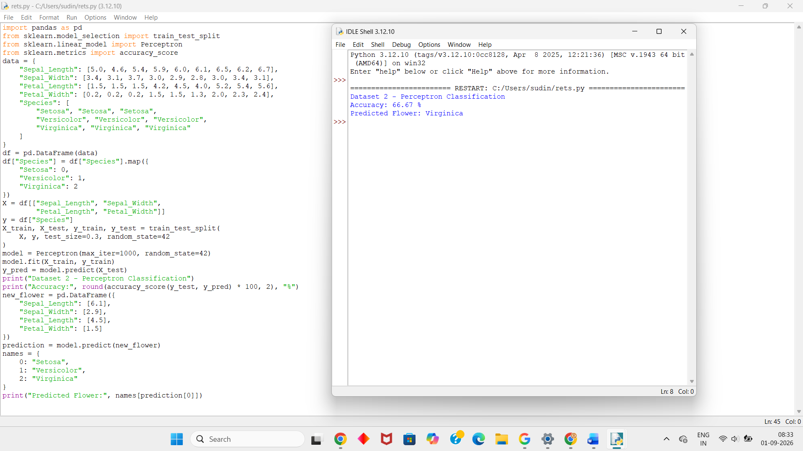
Dataset 3 – Perceptron Based Iris Classification
Sepal Length | Sepal Width | Petal Length | Petal Width | Species
5.2 | 3.4 | 1.4 | 0.2 | Setosa
4.8 | 3.4 | 1.6 | 0.2 | Setosa
5.1 | 3.8 | 1.6 | 0.2 | Setosa
6.0 | 2.7 | 5.1 | 1.6 | Versicolor
5.6 | 2.9 | 3.6 | 1.3 | Versicolor
5.7 | 2.8 | 4.5 | 1.3 | Versicolor
6.8 | 3.2 | 5.9 | 2.3 | Virginica
6.4 | 2.8 | 5.6 | 2.2 | Virginica
6.9 | 3.1 | 5.4 | 2.1 | Virginica
Python Code:
import pandas as pd
from sklearn.model_selection import train_test_split
from sklearn.linear_model import Perceptron
from sklearn.metrics import accuracy_score
data = {
"Sepal_Length": [5.2, 4.8, 5.1, 6.0, 5.6, 5.7, 6.8, 6.4, 6.9],
"Sepal_Width": [3.4, 3.4, 3.8, 2.7, 2.9, 2.8, 3.2, 2.8, 3.1],
"Petal_Length": [1.4, 1.6, 1.6, 5.1, 3.6, 4.5, 5.9, 5.6, 5.4],
"Petal_Width": [0.2, 0.2, 0.2, 1.6, 1.3, 1.3, 2.3, 2.2, 2.1],
"Species": [
"Setosa", "Setosa", "Setosa",
"Versicolor", "Versicolor", "Versicolor",
"Virginica", "Virginica", "Virginica"
]
}
df = pd.DataFrame(data)
df["Species"] = df["Species"].map({
"Setosa": 0,
"Versicolor": 1,
"Virginica": 2
})
X = df[["Sepal_Length", "Sepal_Width",
"Petal_Length", "Petal_Width"]]
y = df["Species"]
X_train, X_test, y_train, y_test = train_test_split(
X, y, test_size=0.3, random_state=42
)
model = Perceptron(max_iter=1000, random_state=42)
model.fit(X_train, y_train)
y_pred = model.predict(X_test)
print("Dataset 3 - Perceptron Classification")
print("Accuracy:", round(accuracy_score(y_test, y_pred) * 100, 2), "%")
new_flower = pd.DataFrame({
"Sepal_Length": [6.8],
"Sepal_Width": [3.2],
"Petal_Length": [5.9],
"Petal_Width": [2.3]
})
prediction = model.predict(new_flower)
names = {
0: "Setosa",
1: "Versicolor",
2: "Virginica"
}
print("Predicted Flower:", names[prediction[0]])
Output:
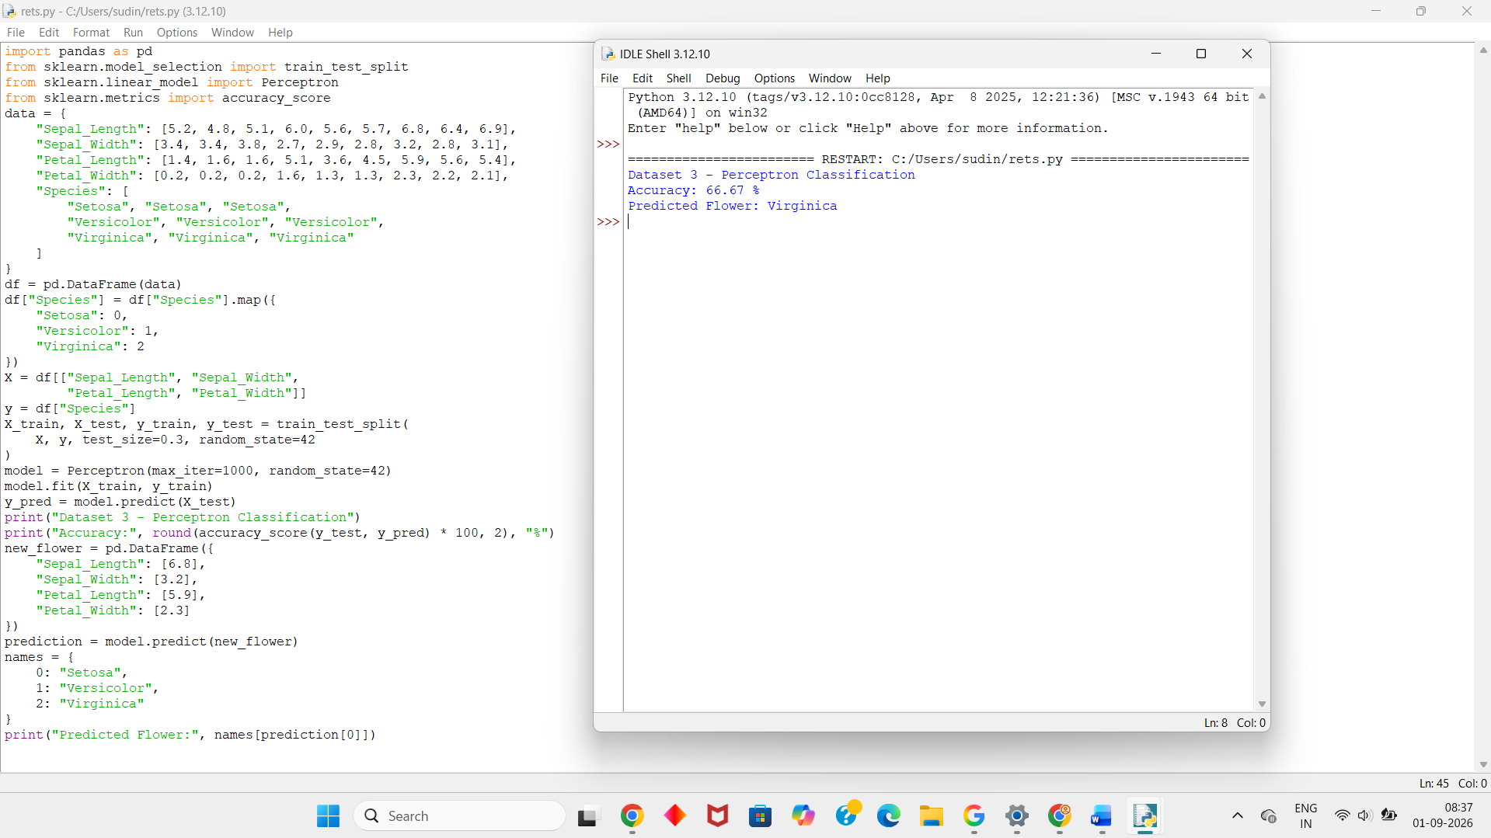
Dataset 4 – Perceptron Based Iris Classification
Sepal Length | Sepal Width | Petal Length | Petal Width | Species
5.3 | 3.7 | 1.5 | 0.2 | Setosa
5.0 | 3.0 | 1.6 | 0.2 | Setosa
4.7 | 3.2 | 1.6 | 0.2 | Setosa
5.8 | 2.7 | 4.1 | 1.0 | Versicolor
6.2 | 2.2 | 4.5 | 1.5 | Versicolor
5.5 | 2.5 | 4.0 | 1.3 | Versicolor
6.7 | 3.3 | 5.7 | 2.1 | Virginica
6.3 | 2.9 | 5.6 | 1.8 | Virginica
7.2 | 3.2 | 6.0 | 1.8 | Virginica
Python Code:
import pandas as pd
from sklearn.model_selection import train_test_split
from sklearn.linear_model import Perceptron
from sklearn.metrics import accuracy_score
data = {
"Sepal_Length": [5.3, 5.0, 4.7, 5.8, 6.2, 5.5, 6.7, 6.3, 7.2],
"Sepal_Width": [3.7, 3.0, 3.2, 2.7, 2.2, 2.5, 3.3, 2.9, 3.2],
"Petal_Length": [1.5, 1.6, 1.6, 4.1, 4.5, 4.0, 5.7, 5.6, 6.0],
"Petal_Width": [0.2, 0.2, 0.2, 1.0, 1.5, 1.3, 2.1, 1.8, 1.8],
"Species": [
"Setosa", "Setosa", "Setosa",
"Versicolor", "Versicolor", "Versicolor",
"Virginica", "Virginica", "Virginica"
]
}
df = pd.DataFrame(data)
df["Species"] = df["Species"].map({
"Setosa": 0,
"Versicolor": 1,
"Virginica": 2
})
X = df[["Sepal_Length", "Sepal_Width",
"Petal_Length", "Petal_Width"]]
y = df["Species"]
X_train, X_test, y_train, y_test = train_test_split(
X, y, test_size=0.3, random_state=42
)
model = Perceptron(max_iter=1000, random_state=42)
model.fit(X_train, y_train)
y_pred = model.predict(X_test)
print("Dataset 4 - Perceptron Classification")
print("Accuracy:", round(accuracy_score(y_test, y_pred) * 100, 2), "%")
new_flower = pd.DataFrame({
"Sepal_Length": [5.8],
"Sepal_Width": [2.7],
"Petal_Length": [4.1],
"Petal_Width": [1.0]
})
prediction = model.predict(new_flower)
names = {
0: "Setosa",
1: "Versicolor",
2: "Virginica"
}
print("Predicted Flower:", names[prediction[0]])
Output:
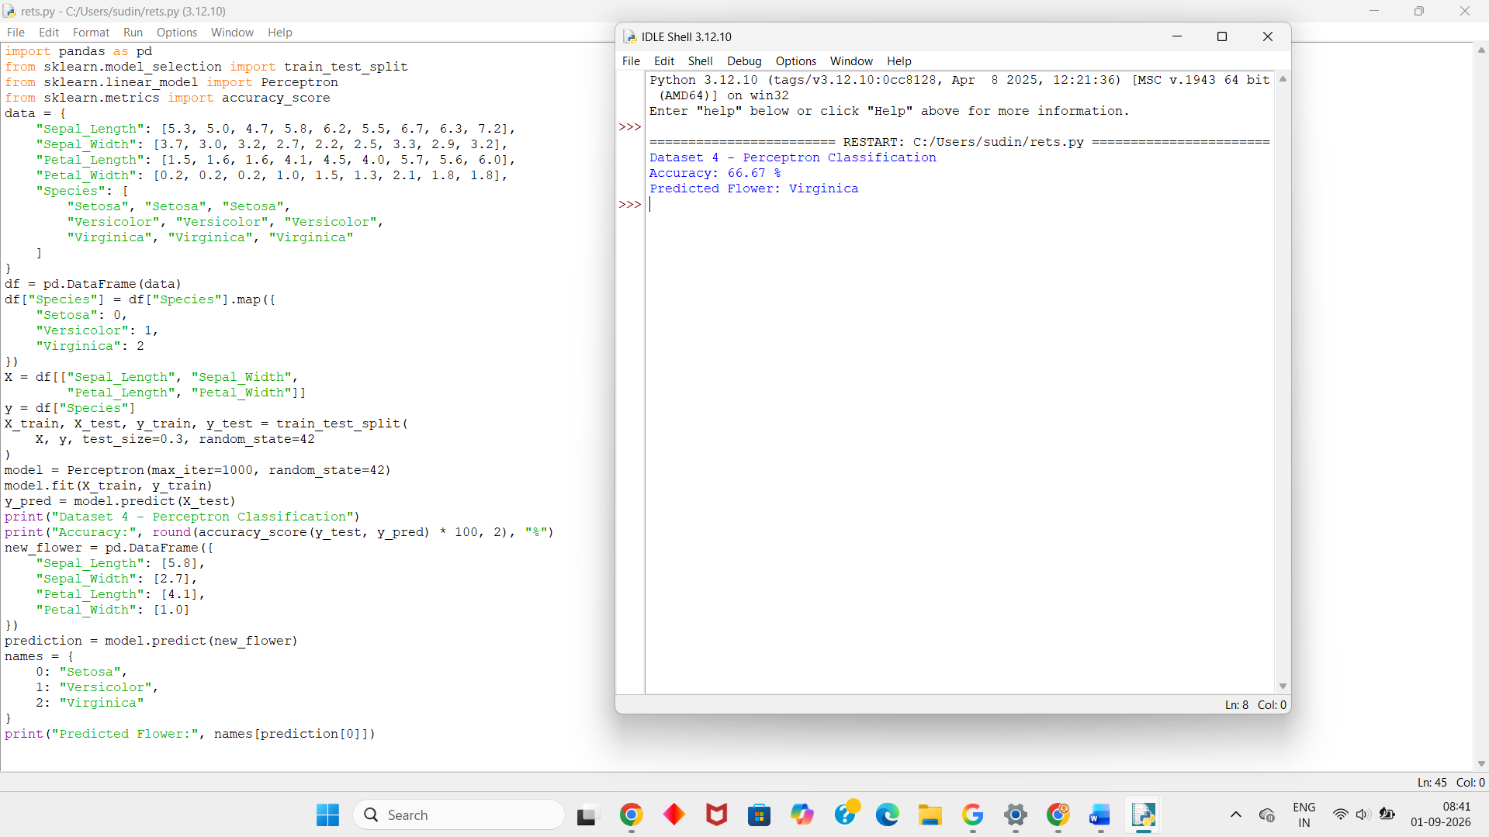
Dataset 5 – Perceptron Based Iris Classification
Sepal Length | Sepal Width | Petal Length | Petal Width | Species
5.4 | 3.4 | 1.7 | 0.2 | Setosa
4.9 | 3.1 | 1.5 | 0.1 | Setosa
5.1 | 3.5 | 1.4 | 0.3 | Setosa
5.7 | 2.9 | 4.2 | 1.3 | Versicolor
6.3 | 2.5 | 4.9 | 1.5 | Versicolor
5.8 | 2.6 | 4.0 | 1.2 | Versicolor
6.4 | 3.1 | 5.5 | 1.8 | Virginica
6.9 | 3.2 | 5.7 | 2.3 | Virginica
7.3 | 2.9 | 6.3 | 1.8 | Virginica
Python Code:
import pandas as pd
from sklearn.model_selection import train_test_split
from sklearn.linear_model import Perceptron
from sklearn.metrics import accuracy_score
data = {
"Sepal_Length": [5.4, 4.9, 5.1, 5.7, 6.3, 5.8, 6.4, 6.9, 7.3],
"Sepal_Width": [3.4, 3.1, 3.5, 2.9, 2.5, 2.6, 3.1, 3.2, 2.9],
"Petal_Length": [1.7, 1.5, 1.4, 4.2, 4.9, 4.0, 5.5, 5.7, 6.3],
"Petal_Width": [0.2, 0.1, 0.3, 1.3, 1.5, 1.2, 1.8, 2.3, 1.8],
"Species": [
"Setosa", "Setosa", "Setosa",
"Versicolor", "Versicolor", "Versicolor",
"Virginica", "Virginica", "Virginica"
]
}
df = pd.DataFrame(data)
df["Species"] = df["Species"].map({
"Setosa": 0,
"Versicolor": 1,
"Virginica": 2
})
X = df[["Sepal_Length", "Sepal_Width",
"Petal_Length", "Petal_Width"]]
y = df["Species"]
X_train, X_test, y_train, y_test = train_test_split(
X, y, test_size=0.3, random_state=42
)
model = Perceptron(max_iter=1000, random_state=42)
model.fit(X_train, y_train)
y_pred = model.predict(X_test)
print("Dataset 5 - Perceptron Classification")
print("Accuracy:", round(accuracy_score(y_test, y_pred) * 100, 2), "%")
new_flower = pd.DataFrame({
"Sepal_Length": [6.9],
"Sepal_Width": [3.2],
"Petal_Length": [5.7],
"Petal_Width": [2.3]
})
prediction = model.predict(new_flower)
names = {
0: "Setosa",
1: "Versicolor",
2: "Virginica"
}
print("Predicted Flower:", names[prediction[0]])
Output:
